IAM PROJECT

(IDENTITY ACCESS AND MANAGEMENT)

**Prepared by: sujijegaprasanthini john paul**

**master of computer secuirty**

**Table of Contents**

**1.0 Introduction………………………………………………………………………………………**

1.1 Scope and Purpose……………………………………………………………

1.2 Prerequisites……………………………………………… …………………….

1.3 Configuration……………………………………………………………………

**2.0 Detailed Process**

Overview………………………………………………………………………………

2.1 Login process………………………………………………………….

2.2 Creation Identities …………………………………………………………………………

2.3 Modify Identities……………………………………………

2.4 Delete Identities ………………………………………………………………………………

2.5 List of Identities……………………………………………

2.6 Exit……………………………………………

**3.0 References…………………………………………………………………………………….**

**1.Introduction**

**1.1Scope and Purpose:**

These project is based on developing Identity Access and Management application. In a short note about this application, it helps users to keep their personal identities in a secured manner without there login details they can’t access their details which was stored in a database(Connected to Derby database). The operation we need to perform in that database using java is creating, updating, deleting and viewing the identities of the user.

**1.2 Prerequisites:**

1. JRE
2. Derby Database Service which have already setup or we can download.

**1.3Configuration:**

Download and Install Derby database and set the JAVA_HOME environment variable to the root location of the JDK installation directory. The examples below use C:\jdk1.7 for Windows but be sure to use the actual location on your system. (e.g. The default installation location used by the JDK installer might be something like C: \> set JAVA_HOME=C:\jdk1.7. Start the derby server by running startNetworkServer.bat from derby installation path %DERBY_HOME%/bin.

**2. Overview**

**2.1 Login:**

These process helps user to access their application by their login and password details. If its correct authentication accepted if its wrong authentication denied.

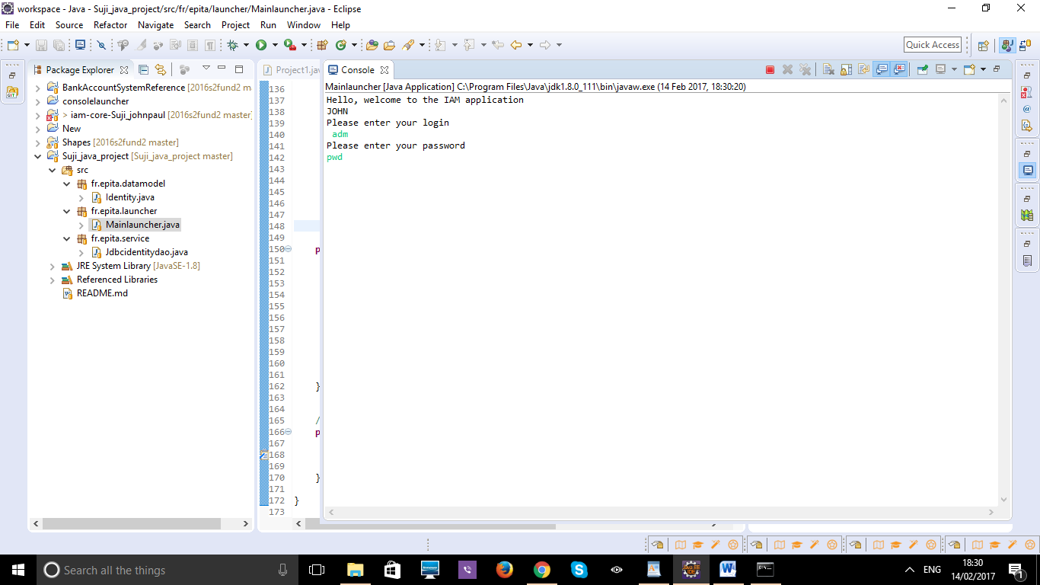

After authentication following menu will be displayed

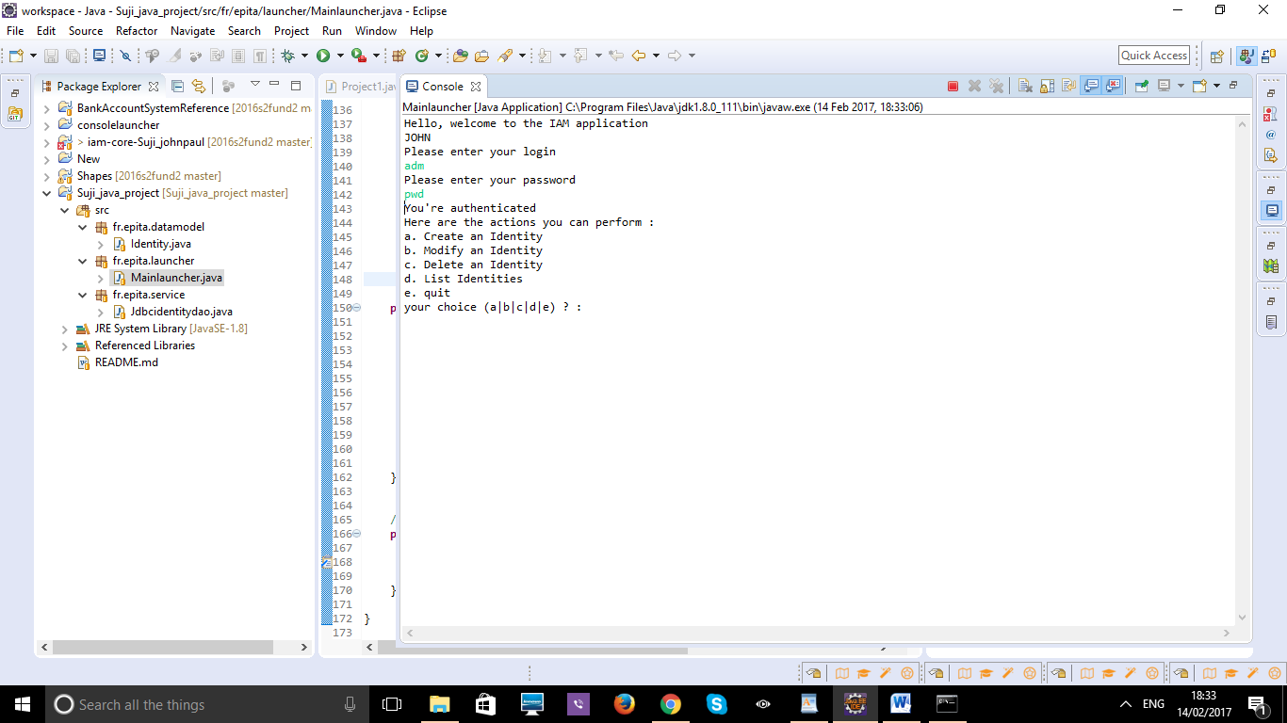

* 1. **Creation Identities:**
* These process helps user to create their identities in the database by selecting the option A.
* For that you need to give input as UID , display name, Email.
* It will create an identity successfully.

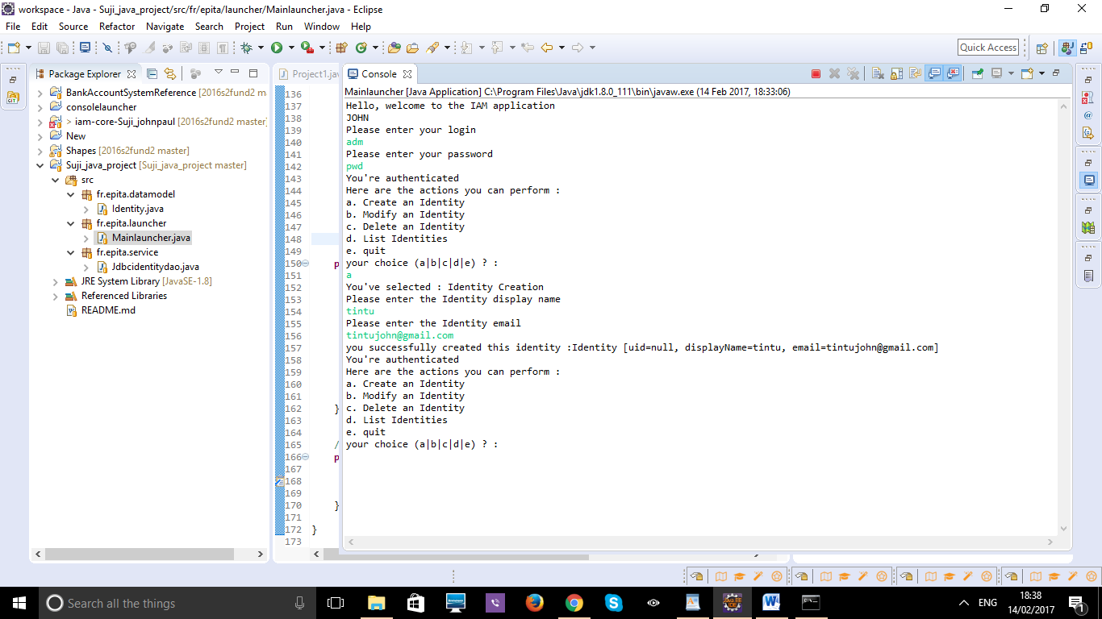

* 1. **Modify Identities:**
* These process helps user to update and modify their identities in the database by selecting option B.
* For that you to give input as UID because UID is a primary key of your identity table so you can update existing identities in the database.
* It will update an identity successfully

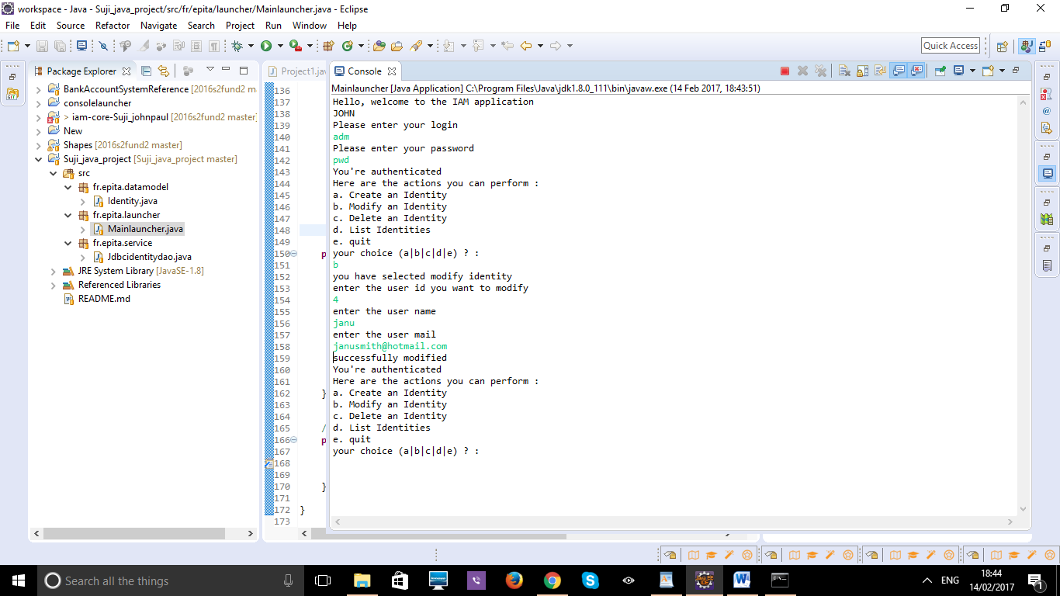

* 1. **Delete Identities:**
* These process helps user to delete particular identity from database using your unique id by selecting option C.
* It will delete an identity successfully.

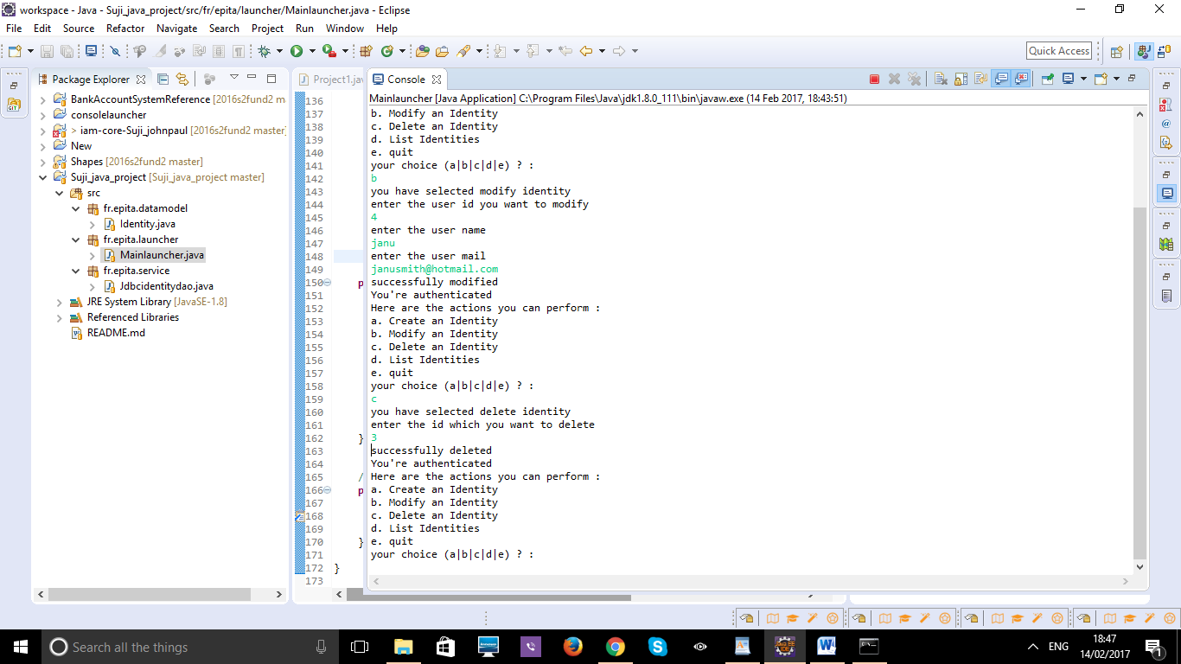

* 1. **List of Identities:**
* These process helps user to the identity which are all created inside database by selecting option D.
* Identities listed successfully.

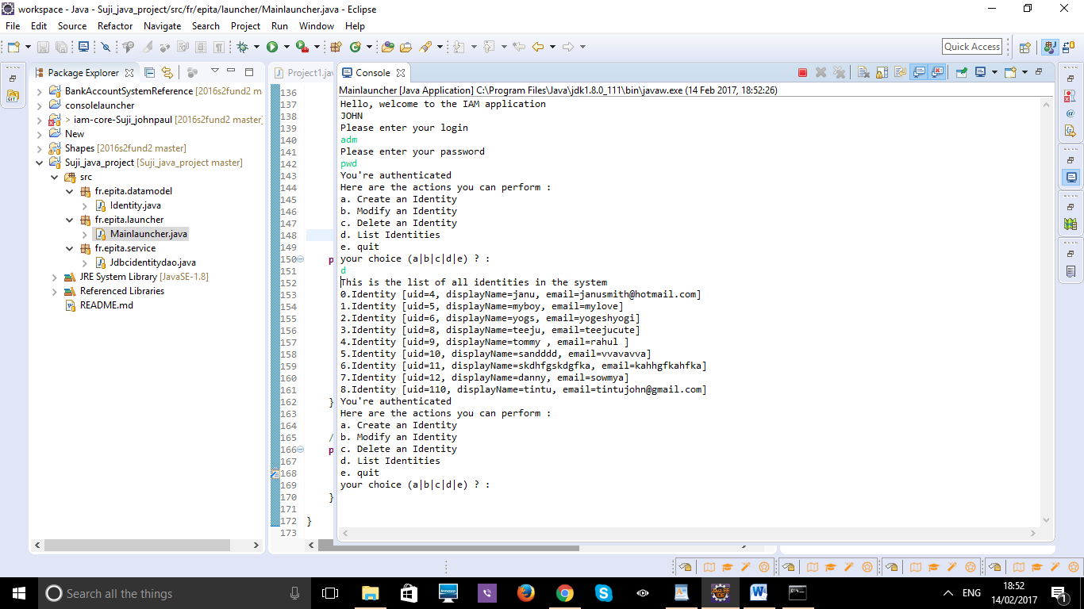

* 1. **Exit:**

Choose option e to exit the application

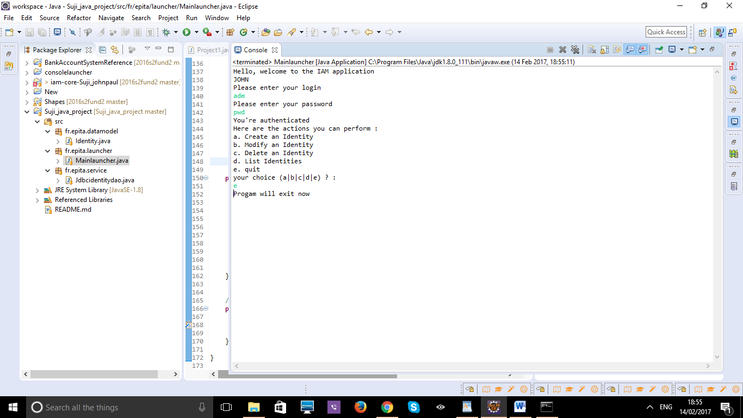

1. **References:**

* <http://thomas-broussard.fr/>
* <http://www.javabeginner.com/java-swing/java-swing-addressbook>
* <http://www.tutorialspoint.com/>
* <https://db.apache.org/derby/derby_downloads.html>